Progress on Japan’s Biological Sampling of
Three Billfish Species caught in the
North Pacific from 2019 to 2025¹

Yuki Ishihara², Marko Jusup² and Mikihiko Kai²

²Fisheries Resources Institute, Highly Migratory Resources Division,
Japan Fishery Research and Education Agency
2-12-4 Fukuura, Kanazawa, Yokohama, Kanagawa 236-8648, JAPAN
Email: ishihara_yuki13@fra.go.jp

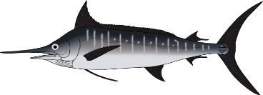
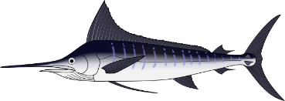
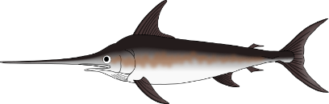

Abstract
In 2020, Japan, the United States, and Taiwan initiated International Billfish Biological Sampling Program (IBBS) to accurately estimate the key life history parameters, such as maturity and growth, of three billfish species—swordfish, striped marlin, and blue marlin—across the North Pacific Ocean. This working paper summarizes the current progress of the biological sampling undertaken by Japan and the number of samples shared with the United States and Taiwan. The total number of gonads, otoliths, and spines collected by Japan from swordfish in the western North Pacific Ocean between January 2019 and November 2025 has reached the predetermined target. However, south of 30°N, there is a substantial bias in the location and size of sampled swordfish. On the other hand, specimens of striped marlin less than 100 cm EFL and greater than 210 cm EFL are scarce. Although efforts to collect these specimens were intensified starting in 2024, none were obtained. The number of swordfish gonad samples from three countries collated by Japan, including both fresh and frozen samples, has reached the target value in the western and central areas. Future studies include establishing a method for analyzing frozen gonads and conducting sampling in areas where only few specimens have been obtained. The number of striped marlin otolith and dorsal spine samples collated by Japan for small and large specimens alike is small across all three regions. Additionally, there are a few large geographic areas where very few samples have been collected. A more efficient sampling plan will be required to collect effectively these missing samples in the future.

Introduction
The ISC Billfish Working Group (BILLWG) formally launched the International Billfish Biological Sampling (IBBS) project in 2020. The project aims to enhance stock assessments of swordfish (Xiphias gladius), striped marlin (Kajikia audax), and blue marlin (Makaira mazara) by improving estimates of biological life history parameters, such as maturity and growth, across the North Pacific Ocean (Kinney et al., 2020). Japan, the United States, and Taiwan are participating in the project, following a standardized protocol for billfish sample collection. In some regions and for some size bins, the number of specimens collected has reached the target value. However, challenges remain, particularly the lack of small and large striped marlin specimens, and the existence of areas where no specimens have been collected (Ishihara et al. 2025).
This working paper summarizes the current progress of biological sampling undertaken by Japan and the number of samples shared with the United States and Taiwan. Future sampling plans are also discussed

Materials and Methods
Japan independently initiated the sampling of gonads, otoliths, dorsal or anal spines, and muscle tissues from swordfish, striped marlin, and blue marlin in January 2019, with lens sampling added in February 2023. For each sampled billfish, fishing information such as capture date and location (latitude and longitude) was recorded. Additionally, eye-fork-length (EFL, in cm) and body weight (kg) were measured. Sampling was generally conducted without regard to sex or body size. However, since April 2023, specimens of swordfish and striped marlin less than 100 cm EFL have been collected in the northwestern Pacific Ocean, and since February 2025, specimens of striped marlin larger than 200 cm EFL have been collected in the northern East China Sea.
Gonad samples were preserved in 10% formalin or ALTFix whenever possible, with the remainder frozen at ‒40°C. Gonad weights were recorded whenever feasible. Otolith samples were extracted from the head in the laboratory and preserved in 70% ethanol. Two to three rays, including the longest, were collected from the dorsal and anal fins, cleaned, and dried. Muscle samples (~0.1–0.2 grams) were excised using a clean scalpel and preserved in Urea buffer. Additionally, tissue pieces (~5×5×5 cm cubes) were collected and frozen at ‒40°C. Lens samples were also gathered and stored frozen at ‒40°C.
The exchange of billfish biological samples among Japan, the United States, and Taiwan commenced in April 2023. Japan provided blue marlin gonad, otolith, and dorsal spine samples to Taiwan, as well as striped marlin gonad and swordfish otolith and anal spine samples to the United States. In return, Japan received swordfish gonads, striped marlin otoliths, and dorsal spines from both Taiwan and the United States. For samples with body length recorded in lower jaw fork length (LJFL) rather than EFL, LJFL was converted to EFL using a linear regression equation (Su et al., 2005).

Results and Discussions
The current progress of biological sampling conducted by Japan
Japan has continued to strengthen sampling of swordfish and striped marlin from 2023 to 2025 (Table 1). However, the collection of blue marlin samples remains minimal. Notably, there is strong bias toward certain length bins and specific sampling locations (Table 1, Figure 1 and Figure 2).
The number of striped marlin samples is particularly high in the western area, and the number of specimens measuring 110-210 cm EFL has nearly reached the predetermined target (Figure 1). However, specimens smaller than 100 cm EFL and larger than 210 cm EFL were scarce in both the western and central regions. From 2024, sampling focused specifically on small and large striped marlin, but no specimens under 100 cm EFL or over 210 cm EFL were collected. Previous sampling locations for western region striped marlin have been biased toward the East China Sea (Ishihara et al. 2025). In 2025, sampling was conducted throughout the year in the northwestern North Pacific, with sampling locations expanded (Figure 2).
Swordfish have previously lacked sufficient specimens of small individual under 75 cm EFL and matured female. In 2025, collection of smaller specimens was intensified, and the number of samples from the western region reached the target value for nearly all size bins (Figure 1). Additionally, sampling throughout the year was conducted in the Ogasawara Islands waters, where mature individuals are expected to be collected (Yamaguchi 2011). Analysis of swordfish maturity in the Ogasawara Islands waters is currently underway. Regarding the sampling locations for swordfish, the number of samples in the western area south of 30°N increased in 2025 (Figure 2). However, most samples from this area outside the Ogasawara Islands waters are smaller than 100 cm EFL.

Current status of biological samples from three countries collated by Japan
Samples collected by Japan, primarily those collected by October 2024, were provided to Taiwan and the United States. Samples from November 2024 onwards will be provided in the next fiscal year (Table 2).
Taiwan primarily supplied samples from the western and central regions, while the United States focused on samples from the central and eastern regions (Table 3). Gonadal samples received from Taiwan were initially frozen and later preserved in formalin. Tissue sections were prepared from these samples and examined, revealing significant tissue damage. The methods for sharing and analyzing frozen gonads will require further consideration in the future.
The number of swordfish gonad samples collected by Japan, Taiwan, and the United States, including both fresh and frozen samples, largely met the length-bin targets in the western and central regions (Figure 3). However, male samples exceeding 200 cm EFL remain notably scarce across all regions. Swordfish gonads have been collected from a broad area in the North Pacific Ocean, however, samples south of 25°N and west of 175°E are scarce, and most of these are frozen samples.
Otolith and spine samples of striped marlin from small specimens (<100 cm EFL) and large specimens (≥210 cm EFL in the western region, and ≥180 cm EFL in the central and eastern regions) are severely underrepresented (Figure 5). Regarding sampling locations, there are areas with insufficient sample sizes in all regions. There is a scarcity of samples south of 29°N and west of 150°W in the western region, and north of 31°N in the central and eastern regions (Figure 6).
Five years have passed since the launch of the IBBS program, and the samples from the three countries have grown substantially. However, future studies should focus on the analysis of frozen reproductive glands from swordfish, sampling of both small and large individuals of striped marlin, and sampling in waters where specimens of both species are lacking. A more efficient sampling plan will be required to collect effectively these missing samples in the future.

References
DeMartini, E.E., J.H. Uchiyama, and H.A. Williams. 2020. Sexual maturity, sex ratio, and size composition of swordfish, Xiphias gladius, caught by the Hawaii-based pelagic longline fishery. Fish. Bull., 98: 489–506.
Ishihara, Y., Jusup, M., Kai, M. 2025. Progress on Japan’s Biological Sampling of Three Billfish Species caught in the North Pacific from 2019 to 2024. ISC/25/BILLWG-01/02.
Kai, M., Ishihara, Y. 2024. Progress report of biological sampling for billfishes collected by Japan in the North Pacific for 2019-2023. ISC/24/BILLWG-1/01.
Kinney, M.J., Chang, Y.J., Ijima, H., Kanaiwa, M., Schemmel, E., and O’Malley, J. 2020. Length-based proportional sampling for life history research: establishing uniform sampling for North Pacific billfish species. ISC/20/BILLWG-02/01.
Kunihisa Yamaguchi. 2011. Fishery biological study on swordfish Xiphias gladius caught
from the Ogasawara Islands waters, southern Japan. Reports of Tokyo Fisheries and Ocean Research 4: 1-28
Su, N.J., Sun, C.L., Yeh, S.Z., Chiang, W.C., Wang, S.P. and Liu, C.H. 2025. LJFL and EFL relationships for the billfishes caught by the Taiwanese offshore and coastal fisheries. ISC/05/MAR&SWO-WGs/4.
Table 1. Number of biological samples of three billfish species in the North Pacific Ocean collected by Japan from January 2019 to November 2025.
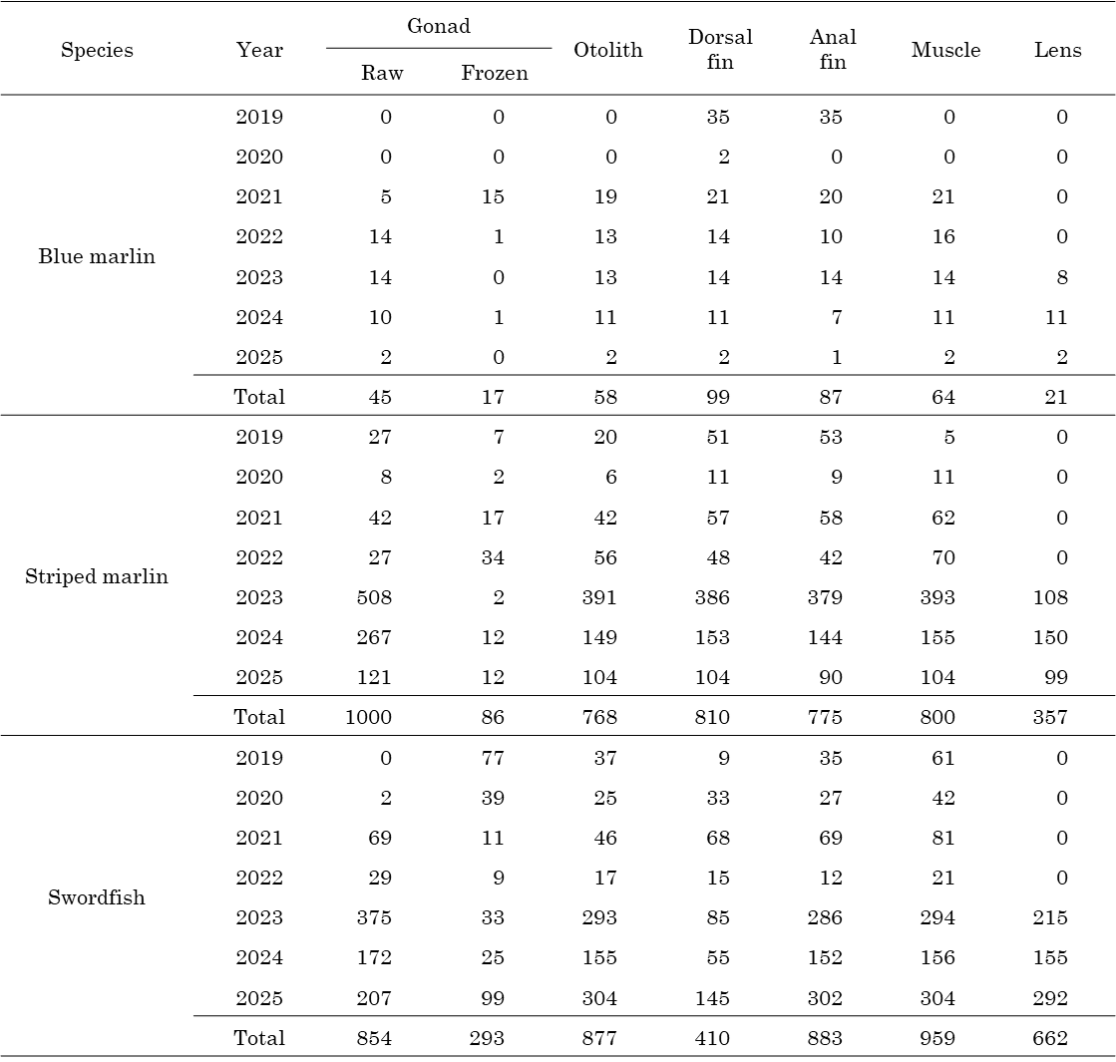

Table 2. Number of biological samples of three billfish species in the North Pacific Ocean collected by Japan from January 2019 to November 2025 that were provided to Taiwan and the United States. 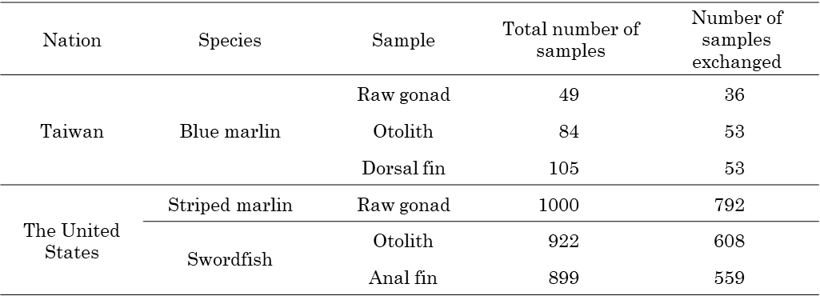

Table 3. Number of swordfish gonads and striped marlin otoliths and dorsal spine samples from three countries collated by Japan. 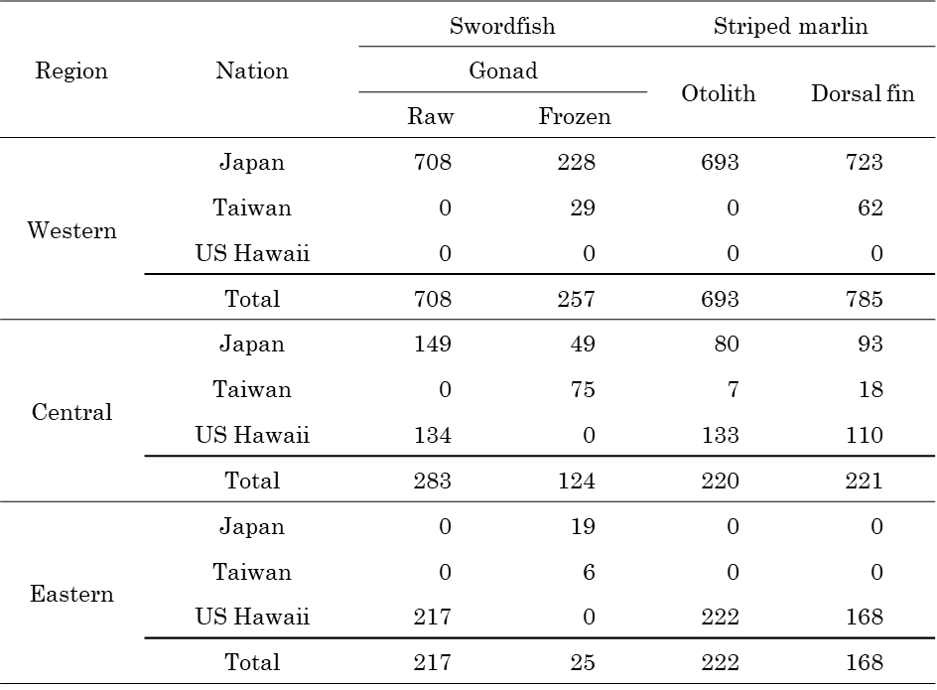
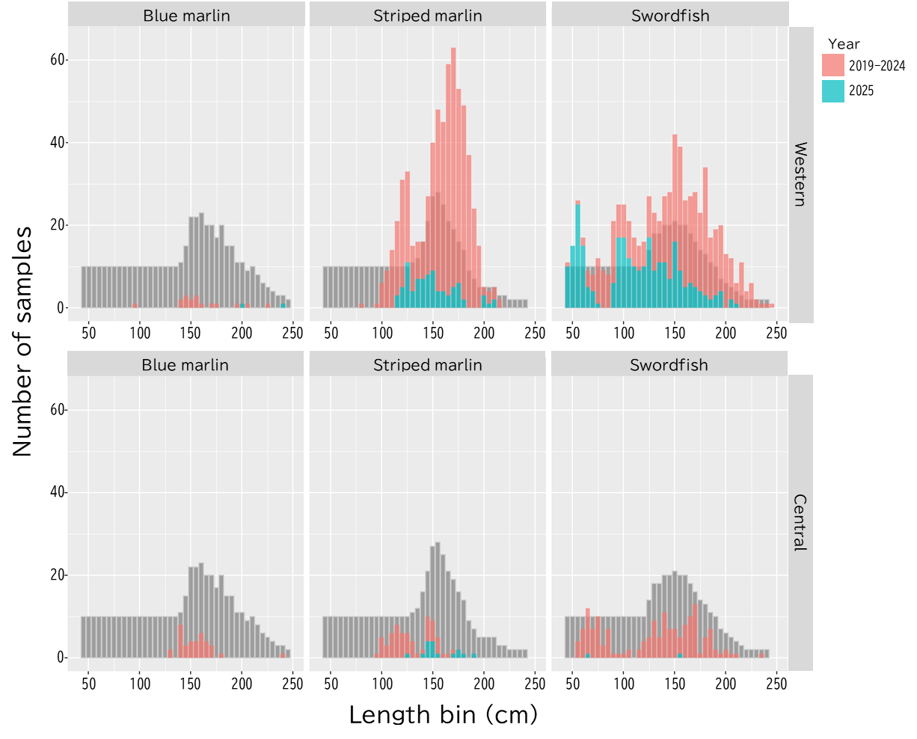
Figure 1. Size frequency distribution (5 cm bins) by year (2019-2024, 2025), including the corresponding targets (grey bars), for three billfish species collected by Japan in the western and central north Pacific Ocean from January 2019 to November 2025.
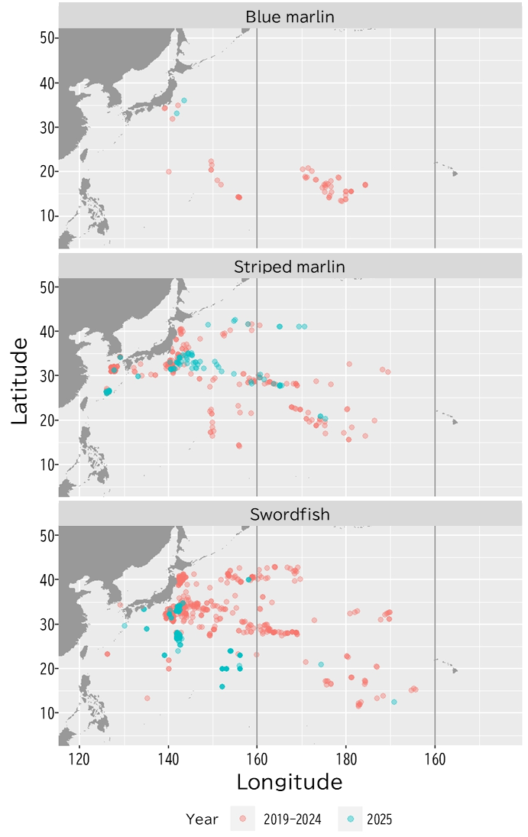
Figure 2. Sampling locations by year (2019-2024, 2025) for three species collected by Japan in the north Pacific Ocean from January 2019 to November 2025.
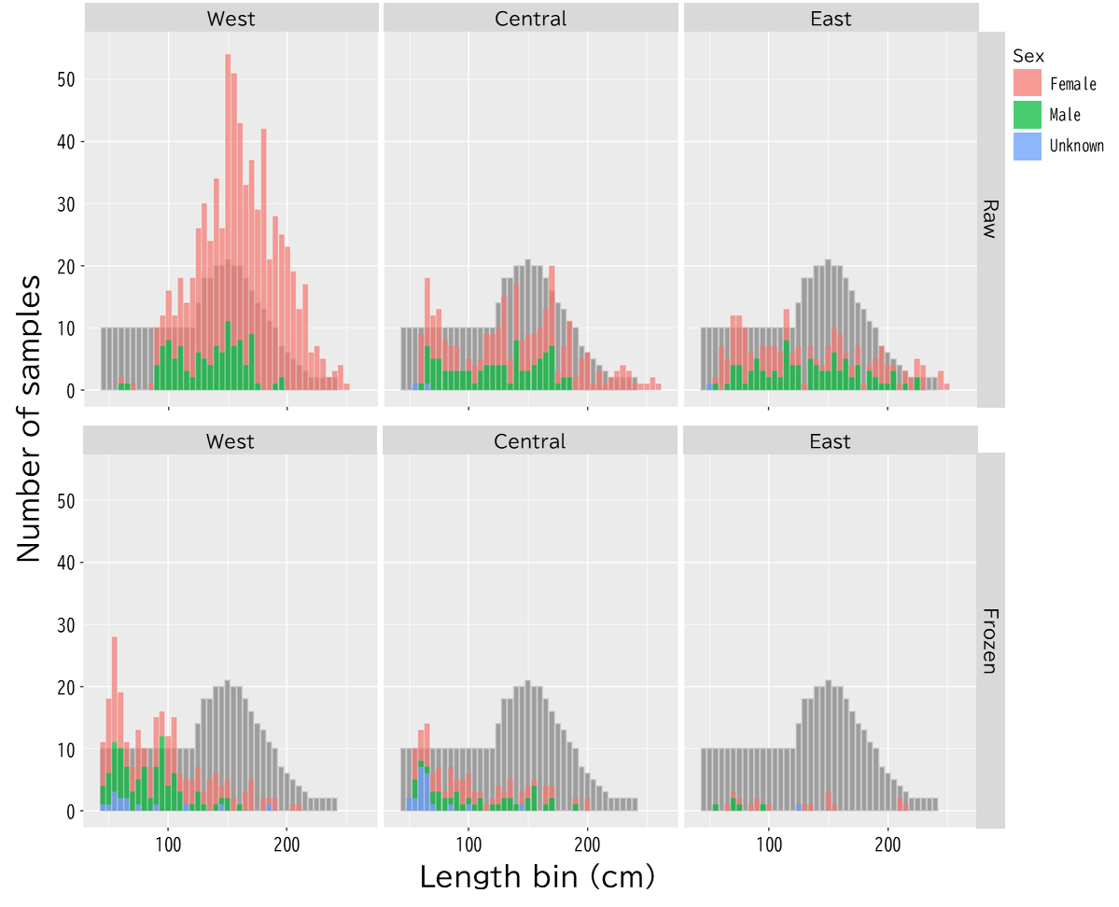Figure 3. Size frequency distributions (5 cm bins) by sex (female, male, and unknown), preservation method (raw and frozen), and region (west, central, and east Pacific Ocean), including the corresponding targets (grey), for swordfish collated by Japan for gonad extraction.
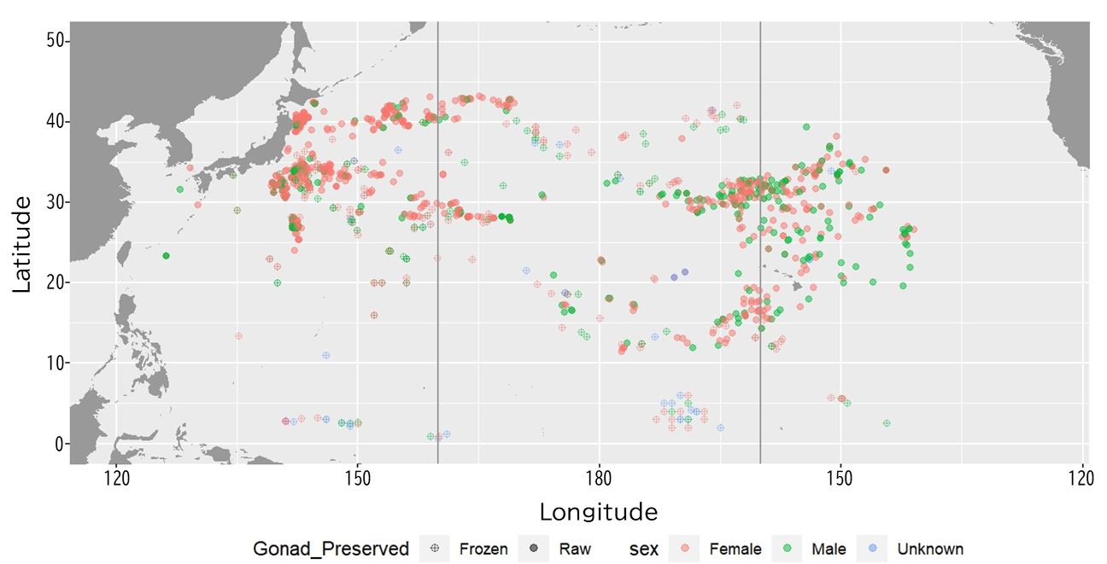
Figure 4. Sampling locations by sex (female, male, and unknown) and preservation method (frozen and raw) for swordfish collated by Japan for gonad extraction.
(a)
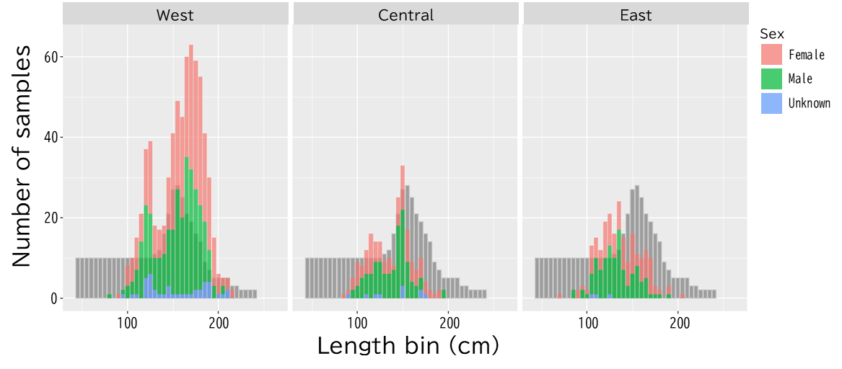
(b)
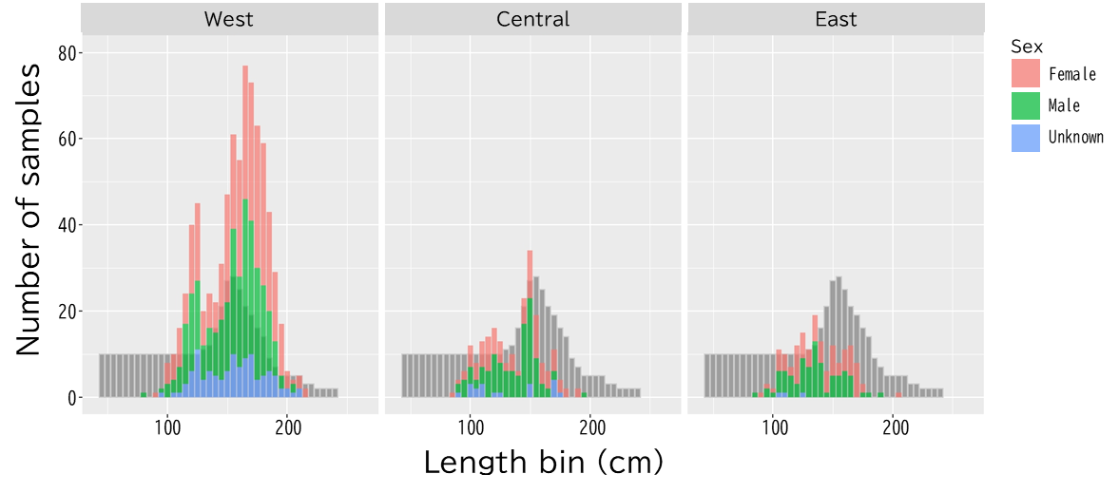
Figure 5. Size frequency distributions (5 cm bins) by sex (female, male, and unknown) and region (west, central, and east North Pacific Ocean), including the corresponding targets (grey), for striped marlin collated by Japan for (a) otolith and (b) dorsal spine extraction.
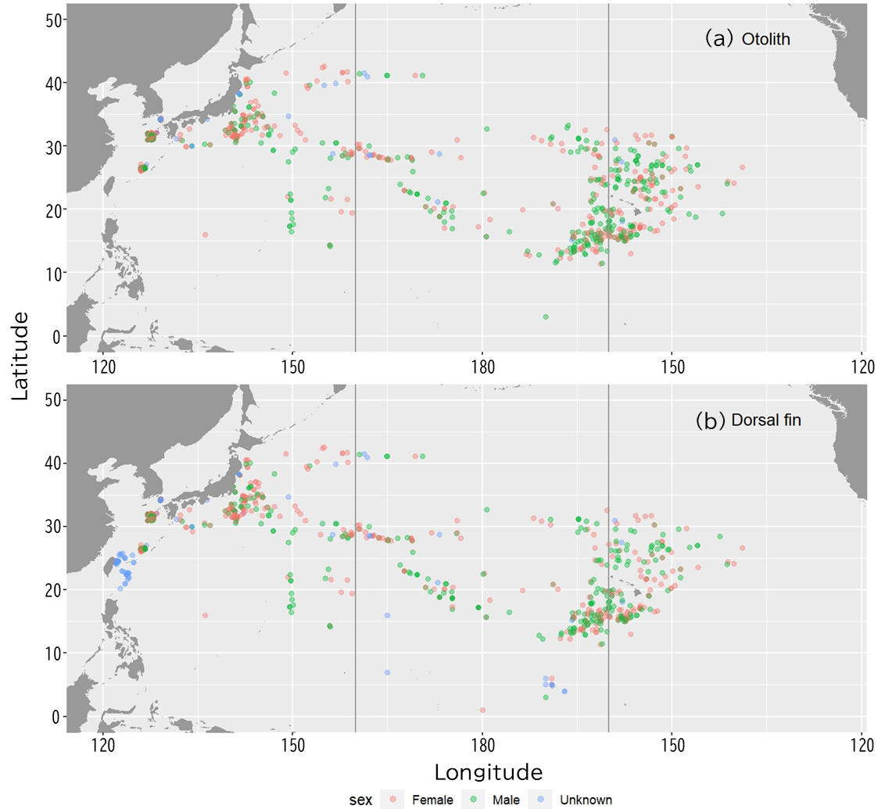
Figure 6. Sampling locations by sex (female, male, and unknown) for striped marlin collated by Japan for (a) otolith and (b) dorsal spine extraction.

